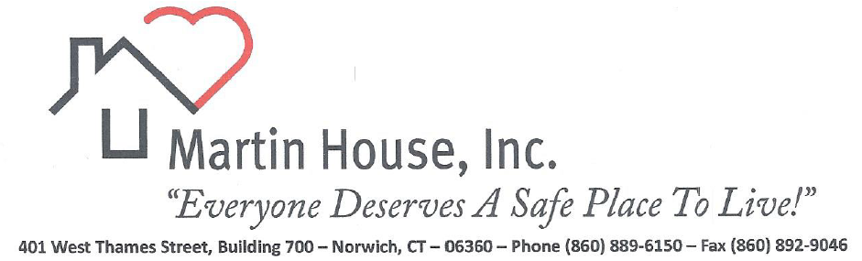

Dear Friends of Martin House,

Board of Directors
Eric McDermott
President
Shelia D. Coleman
Vice President
Debbie Eskra
Secretary
Gayle O’Neill
Treasurer

Elle Crichton
Keith Lee
Mathew Lisee
Courtney MacNeill
Richard Pascal
Marilynn St. Onge
Louise Summa
The State of Connecticut conducted its annual statewide Point-in-Time (PIT) Count of people experiencing homelessness and unfortunately, for the first time in nearly a decade, homelessness in Connecticut rose by 13%. This makes it even more important to continue to do the work we do and to expand services. As we move into the New Year, the Board of Directors and staff at Martin House are working tirelessly to develop strategies to lessen the impact of this crisis. We hope to enhance our services in ways that allow us to have a greater impact on this at-risk population, but we need your help to do so!
I’d like to end this message with a story of what life could be like for some of that 13% if we could expand services.
Meet Donald, a 39-year-old resident at Martin House. Donald started experiencing auditory hallucinations at 15 and left home at 17. He spent several years incarcerated for various offenses, then spent time in a variety of residential facilities that ultimately weren’t right for him before moving to Martin House. A few months back, without notifying staff, Donald spent a few days with a family member. While residents are not required to inform staff of their whereabouts, we were concerned about him. Upon his return, Donald was approached by staff and asked where he had been. Donald put his guard up instantly, probably an instinct based on his history, however, staff let him know, “Donald, we were worried about you.” Donald was obviously taken aback by someone’s concern for him and his response was, “Really? You care about what happens to me?” Never having had a caring environment such as this, he was absolutely awestruck by the outpouring of support.
Supporting our residents is the ‘why we do what we do’, and YOU are the ‘how’. You are an essential piece of the puzzle for Martin House by supporting a space where everyone feels welcome, not judged on their past or mental health status, or identified by their disability but who they are as a human being. Your support makes it imaginable for us to think broader, dream bigger and challenges us to do better.
We are wishing you all a happy and healthy holiday season!
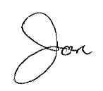
Cordially,

Jon Maderia
Executive Director

Yes, I want to help support the Martin House Community!

Enclosed is my check payable to Martin House Please charge my MasterCard/Visa $
One-Time / Monthly Card # Expiration: CSC #:

Name:
Address: Suggested Donations
$250 $150
Email _________________________ $100 $ 50
$ 25 Other

Please share our story, follow us on Facebook and visit our website at www.martinhousect.org.
Thank you for your support!

P. O. Box 857
401 West Thames Street, Building 700
Norwich, CT 06360

Non-Profit
Organization
US POSTAGE
PAID
Norwich, CT
Permit 133
No.

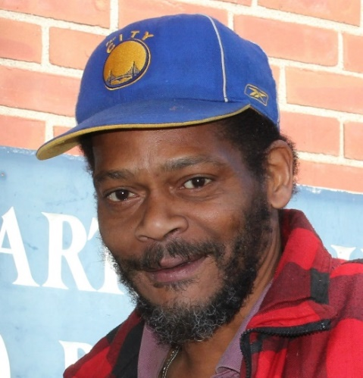

In Loving Memory
Willis Presley
November 17, 1960 - November 6, 2022

